Hospital System Overview & Tool Setup

Hospital System Overview

Hospital System is a simple Java application for managing a hospital by checking in and out patients and doctors. This project was created as a sample project for this lab, therefore it should not be looked at as a complete system.

HospitalSystem allows you to:
- Add a doctor who is then automatically assigned to his favourite room. If the room is occupied, he/she is assigned to the first room available.
- Add a patient who is then automatically assigned to a doctor's waiting list with the desired specialty. If no such doctor is checked in, the patient is assigned to a general practitioner or, if no general practitioner is checked in, to the doctor with the shortest waiting list.
- Check out a doctor who’s room is then freed and all patients added to the waiting list of the doctor with the shortest queue.
- Check out a patient.
- All checked in patients and doctors can be seen in the Overview tab.
- An overview of the rooms in the hospital can be seen in the Running rooms tab.

Add HospitalSystem to your workspace
- Launch Eclipse.
- Unzip “HospitalSystem.zip” to a known location on your hard drive.
- In Eclipse, navigate to “File > Import”.
- Select “General > Existing Projects into Workspace” and click “Next”.
- Click “Browse” and navigate to the location where you extracted “HospitalSystem”.
- “HospitalSystem” should be visible in the “Projects” box, select it and click “Finish”
(Note: You should also see short videos on Blackboard for help with Eclipse.)

Add SpotBugs to Eclipse
- In Eclipse, navigate to “Help > Eclipse Marketplace”.
- Write “SpotBugs” to the “Find” field.
- Look up “SpotBugs Eclipse Plugin 3.1.9” from the search results.
- Select “Install > Confirm > I accept … > Finish > OK”.
- Restart Eclipse.
- Navigate to “Window > Preferences > Java > SpotBugs”.
- Set “Minimum rank to report” to 20.
- Set “Minimum confidence to report” to “Low”.
- Mark all categories from “Reported (visible) bug categories” to true.
- Set all options from “Mark bugs with … rank as” to “Info”.
(Note: You should also see short videos on Blackboard for help with Eclipse.)
After these steps your preferences window should look like the following:
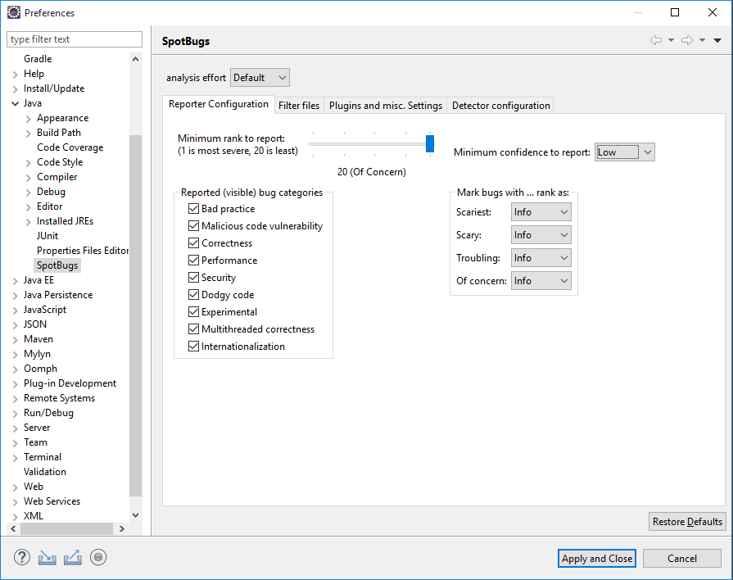
Figure 1 - SpotBugs preferences
- Click “Apply and Close”

Run SpotBugs

- Right click on the “HospitalSystem” project in the package explorer.
- Select “Spot Bugs > Find Bugs” from the context menu.
- Wait for SpotBugs to finish.
- In the top right corner select Click on the “Bug Icon”

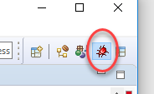

You should now see the SpotBugs perspective:

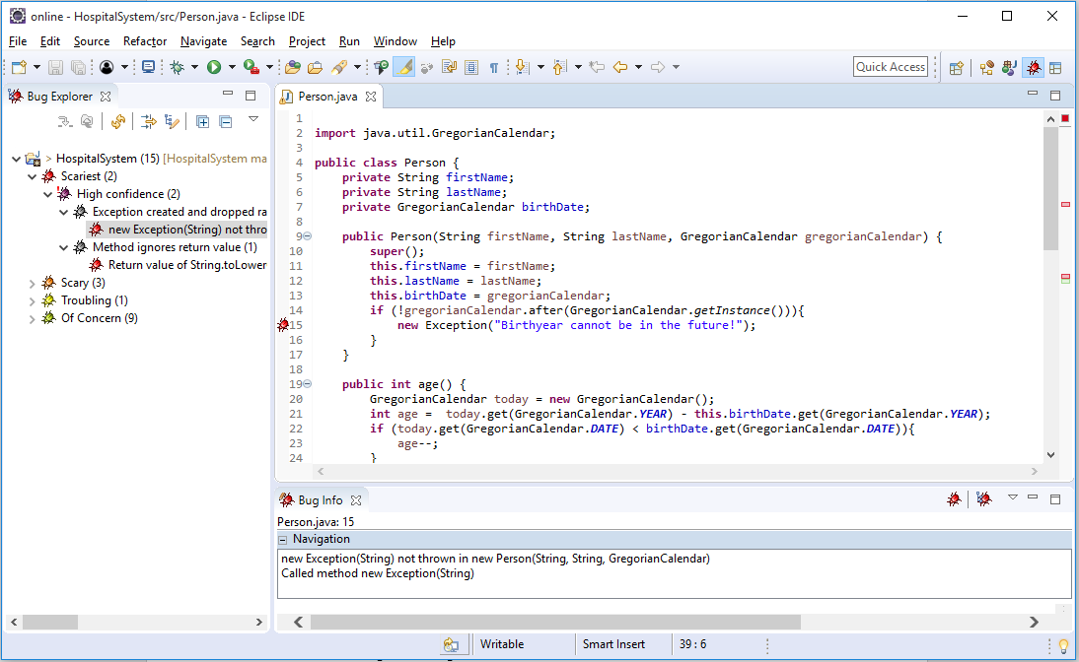
Figure 2 - SpotBugs perspective

Explore Bugs
You can see all the information about bugs that have been found by SpotBugs in the code of the project in the SpotBugs perspective. To see a list of the problems, click on the small arrow in front of “HospitalSystem” in the “Bug Explorer” pane.

SpotBugs categorizes bugs in three main ways.
- Rank - a bug’s rank measures the severity of the problem. It varies from 20 (lowest) to 1 (highest) and the values are grouped into four categories: Of Concern, Troubling, Scary and Scariest.
- Confidence - a bug’s confidence measures the likelihood that a real bug was flagged rather than a false-positive. They are grouped into three categories: High, Normal and Low Confidence.
- Category - a bug’s category notes the bug type. There are nine categories in total, some examples being Correctness, Bad Practice, Performance etc. In addition, SpotBugs matches every bug with a pattern. If interested, you can read more about patterns here: https://spotbugs.readthedocs.io/en/latest/bugDescriptions.html

In Eclipse you can find individual bugs by navigating through the hierarchy of found problems
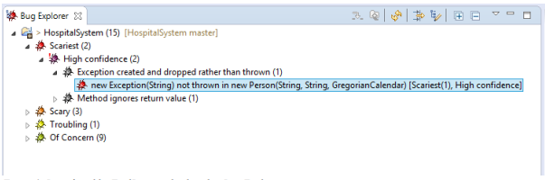
Figure 3. Bugs found by SpotBugs as displayed in Bug Explorer

After clicking on the bug description once, SpotBugs navigates you to the location of the problem in code and further information about it is located in the “Bug Info” tab as shown below.
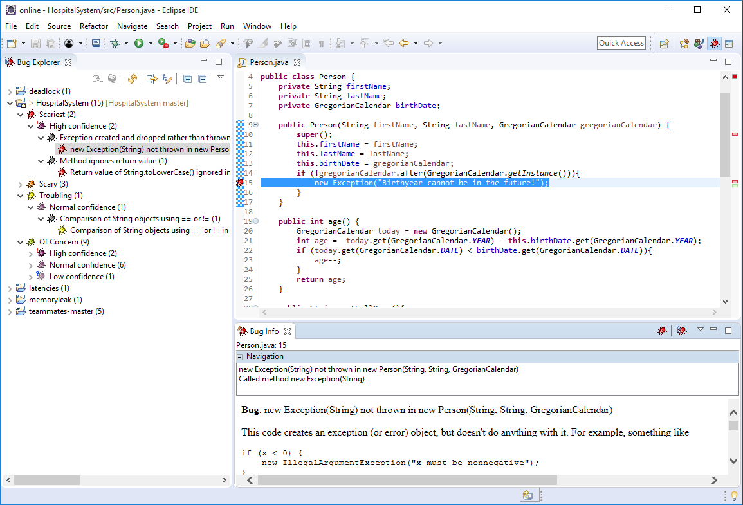
Figure 3. Information about a single bug

If there happens to be two bugs on the same line, a single click on the bug description will show you information about one of them, a double click about the other.

